37.24: Solving Eq. (37.25) for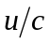, (see solution to Exercise 37.25)
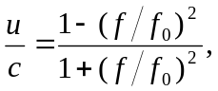
and so (a) if 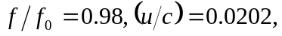 the source and observer are moving away from each other. b) if 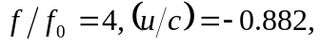 they are moving toward each other.

